##### **Wild Plant Edibility Prediction Using CNNs**

**And IBM Watson Studio**

**A PROJECT REPORT**

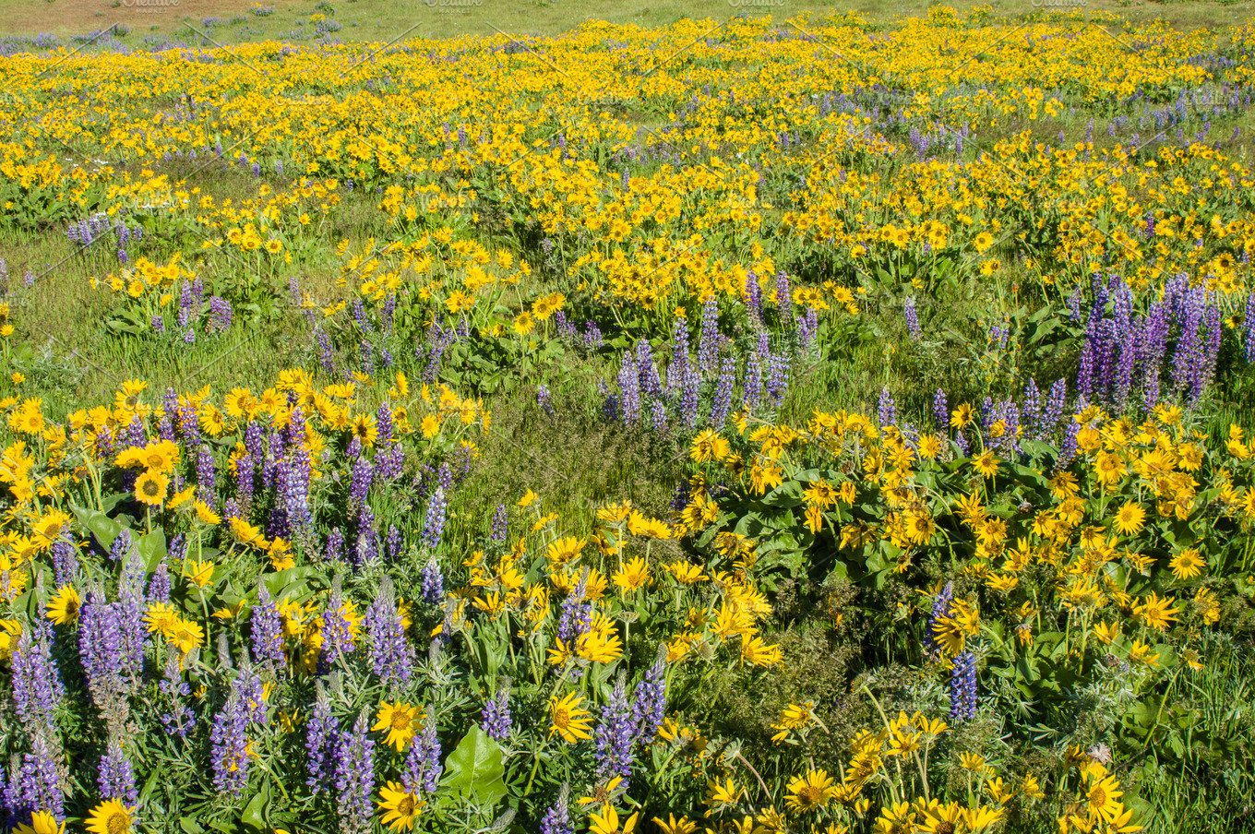

###### 

###### **Submitted by**

**Asmi Panigrahi (19BAI10185)**

**Sapratibh Dev Mahanta (19BCY10112)**

**Under Guidance by All SmartInternz Mentors**

JANUARY 2022

**TABLE OF CONTENTS**

|  |  |  |
| --- | --- | --- |
| **CHAPTER NO.** | **TITLE** | **PAGE NO.** |
|  | **Abstract** | 5 |
| 1 | **CHAPTER-1:**  **PROJECT DESCRIPTION AND OUTLINE** **Introduction** | 6 |
| 2 | **CHAPTER-2:**  **RELATED WORK INVESTIGATION**  2.1 Introduction  2.2 Existing Approaches/Methods  2.3.1 Approaches/Methods -1  2.3.2 Approaches/Methods -2  2.3.3 Approaches/Methods -3  2.3.4 Approaches/Methods -4  2.5 Issues/observations from investigation  2.6 Summary | 8 |
| 3 | **CHAPTER-3:**  **METHODOLOGY AND WORKFLOW**  3.1 Introduction | 12 |
| 4 | **CHAPTER-4:**  **Overall Architecture of the CNN Model**  4.1 Architecture Explanation | 14 |
| 5 | **CHAPTER-5:**  **Experimental Procedure of the CNN Model** | 15 |
| 6 | **CHAPTER-6:**  **PROJECT OUTCOME AND RESULTS** | 19 |
| 7 | **CHAPTER-7:**  **CONCLUSIONS AND RECOMMENDATION**  7.1 **Conclusive Remarks**  7.2 Future Enhancements | 21 |
|  | References | 23 |

**ABSTRACT**

The rural communities of developing countries depend on wild edible plants to meet their food requirements during periods of food shortage. Wild edible plants are mostly serving as supplementary foods in different parts of the world because they are nutritionally rich and can supplement especially vitamins and micro nutrients.

Therefore, with the use of Convolution Neural Networks(CNN), we created a Flask application where the user selects the image which is to be classified. The image is fed into the model that is trained and the predicted class will be displayed on the webpage.

**PROJECT DESCRIPTION AND OUTLINE**

**1.1 Introduction**

To determine, using Convolutional Neural Networks whether a plant or weed is edible or not using only a picture of it. Also determine the species of the plant or weed uploaded. To create a web application that is easy to use and effective in conveying the information about the plant uploaded.

Wild edible plants (WEPS) refer to plant species that are not cultivated or domesticated but are accessible from various natural habitations and used as food .WEPs are generally gathered from diverse habitats, viz, forests, cultivable fields, and even anthropogenic ally disturbed zones like roadsides and wastelands by different traditions throughout the world.

A huge number of ethnic communities and local populace residing in the developing countries draw a significant part of their subsistence and livelihood from wild plants . Historically, humans may have utilized more than 7000 WEPs so far, but many such food resources and valuable plants are still to be explored. Despite the fact that most of the societies primarily rely upon agricultural crops, the tradition of utilization of WEPs has not completely vanished.

According to Food and Agricultural Organization (FAO) report, at least one billion people are thought to use wild food in their diet. WEPs have important role to play in poverty eradication, security of food availability, diversification of agriculture, generation of income resources, and alleviation of malnutrition. The high nutrient and vitamin value of many WEPs reduces the susceptibility of local societies to food insecurity thereby furnishing a safeguard in times of food scarcity, famine, or conflict.

**Proposed Solution**

**2.1 Introduction**

Artificial Intelligence has been witnessing a monumental growth in bridging the gap

between the capabilities of humans and machines. Researchers and enthusiasts alike, work on numerous aspects of the field to make amazing things happen. One of many such areas is the domain of Computer Vision.

The agenda for this field is to enable machines to view the world as humans do, perceive it in a similar manner and even use the knowledge for a multitude of tasks such as Image & Video recognition, Image Analysis & Classification, Media Recreation, Recommendation Systems, Natural Language Processing, etc.

The advancements in Computer Vision with Deep Learning has been constructed and perfected with time, primarily over one particular algorithm - a Convolutional Neural

Network.

A Convolutional Neural Network (ConvNet/CNN) is a Deep Learning algorithm which can take in an input image, assign importance (learnable weights and biases) to various aspects/objects in the image and be able to differentiate one from the other.

The pre-processing required in a ConvNet is much lower as compared to other classification algorithms. While in primitive methods filters are hand-engineered, with enough training, ConvNets have the ability to learn these filters/characteristics.

The architecture of a ConvNet is analogous to that of the connectivity pattern of Neurons in the Human Brain and was inspired by the organization of the Visual Cortex. Individual neurons respond to stimuli only in a restricted region of the visual field known as the Receptive Field.

A collection of such fields overlap to cover the entire visual area.

**2.2 Existing Approaches/Methods**

**Paper 1: Face image recognition based on convolutional neural network**

With the continuous progress of The Times and the development of technology,

the rise of network social media has also brought the "explosive" growth of image

data. As one of the main ways of People's Daily communication, image is widely

used as a carrier of communication because of its rich content, intuitive and other

advantages. Image recognition based on convolution neural network is the first

application in the field of image recognition.

A series of algorithm operations such as image eigenvalue extraction, recognition and convolution are used to identify and analyze different images.

The rapid development of artificial intelligence makes machine learning more and more important in its research field.

Use algorithms to learn each piece of data and predict the outcome. This has become an important key to open the door of artificial intelligence. In machine vision, image recognition is the foundation, but how to associate the low-level information in the image with the

high-level image semantics becomes the key problem of image recognition.

Predecessors have provided many model algorithms, which have laid a solid

foundation for the development of artificial intelligence and image recognition. The

multi-level information fusion model based on the VGG16 model is an improvement

on the fully connected neural network. Different from full connection network,

convolutional neural network does not use full connection method in each layer of

neurons of neural network, but USES some nodes for connection. Although this

method reduces the computation time, due to the fact that the convolutional neural

network model will lose some useful feature information in the process of

propagation and calculation, this paper improves the model to be a multi-level

information fusion of the convolution calculation method, and further recovers the

discarded feature information, so as to improve the recognition rate of the image.

VGG divides the network into five groups (mimicking the five layers of AlexNet), yet it

USES 3*3 filters and combines them as a convolution sequence. Network deeper

CNN, channel number is bigger. The recognition rate of the model was verified by

ORL Face Database, BiolD Face Database and CASIA Face Image Database.

**Paper 2:****Human Motion Recognition Based on Improved 3-Dimensional Convolutional**

In recent years, deep Convolutional neural networks(CNNs) have made fantastic

progress in static image recognition, but the ability to model motion information on

behavioral video is weak. Therefore, our paper put forward a new time transition layer

that models variable temporal convolution kernel depths. We embed this new Hybrid

Model in our proposed 3D CNN. We extend the DenseNet architecture with 3D filters

and pooling kernels. It will take time as training a 3D convolutional neural network

requires a large number of tagged data sets to start training from the input.

Therefore, the focus of this paper is on simple and effective technique of passing 2D

convolutional neural network pre-trained data to a randomly initialized 3D

convolutional neural network for stable weight initialization, where we can still

achieve our experimental results by appropriately reducing the number of 3D

convolutional neural network training samples. Experiments show that the network

can make a more accurate classification of behavioral video, identify it in the

UCF-101 database, and compare it with other classical algorithms that have

appeared in recent years. The results reflect the superiority of the algorithm.

**Paper 3 - Small-scale image recognition based on Cascaded Convolutional Neural Network**

The advent of the era of big data and the rapid improvement of computer computing

capabilities have promoted the development of image recognition technology in a

more advanced direction. Image recognition technology based on deep learning has

become a current research hotspot in the field of artificial intelligence. As one of the

algorithms of deep learning, convolutional neural network has been widely used in

the field of image recognition due to its superior performance. This paper designs a

convolutional neural network that can take into account model size and accuracy. It

is suitable for small-scale image recognition and is convenient for deployment in

some environments with low hardware platforms. Based on the improvement of the

classic ALexNet network, a parallel convolutional structure is used to design a

parallel cascaded convolutional network based on jumper connections for

small-scale image recognition. Parallel convolution uses convolution kernels of

different scales to extract features in parallel, and cascade fusion the features

extracted from different scales. In order to further improve the accuracy, the network

was optimized by adding a layer connection, and the network performance was

evaluated on the Caltech-256 and Food-101 data sets.

The results show that compared with the classic AlexNet network, the network RPCNet constructed based on the layer connection has improved accuracy by 6.12% and 12.28%, respectively, and the network scale is only 1/15 of the ALexNet network.

**Paper 4 - Convolutional Neural Network Approach to Lung Cancer Classification**

**Integrating Protein Interaction Network and Gene Expression Profiles**

Deep learning technologies are permeating every field from image and speech

recognition to computational and systems biology. However, the application of

convolutional neural networks to 'omics' data poses some difficulties, such as the

processing of complex networks structures as well as its integration with

transcriptome data. Here, we propose a convolutional neural network (CNN)

approach that combines spectral clustering information processing to classify lung

cancer. The developed spectral-convolutional neural network based method achieves

success in integrating protein interaction network data and gene expression profiles

to classify lung cancer. Data and CNN code can be downloaded from the link:

https://sites.google.com/site/nacherlab/analysis.

After surveying the proposition and results of these papers we have concluded that

using Convolutional Neural Networks would be ideal for the problem statement.

**Methodology and Work Flow**

**3.1 Introduction**

the user interacts with User interface to upload image then the uploaded image is analyzed by the model which is integrated.

Once model analyses the uploaded image, the prediction is showcased on the UI

The methods and work flow used for the execution of the CNN model are as follows:-

* **Data Collection**:
  + We collected the given dataset from Project Workspace.
* **Data Preprocessing**:
  + It was done by using the ImageDataGenerator library.
  + Import the ImageDataGenerator library
  + Configure ImageDataGenerator class
  + Apply ImageDataGenerator functionality to Trained images and Tested images
* **Model Building**:
  + We built the model using required libraries and worked on the accuracy to give correct predictions.
  + Import the model building Libraries
  + Initializing the model
  + Adding Input Layer
  + Adding Hidden Layer
  + Adding Output Layer
  + Configure the Learning Process
  + Training and testing the model
  + Optimize the Model
  + Save the model
* **Application Building**:
  + We built the application using HTML, CSS and Javascript. Flask was used as the server to launch the application.
  + Create an HTML file
  + Build Python Code

**Overall Architecture of the CNN Model**

**4.1 Explanation of the architecture**

We are building a Flask Application which needs HTML pages stored in the templates folder and a python script app.py for server side scripting. We need the model which is saved and the saved model in this content is major1.h5

The static folder will contain js and css files. Whenever we upload an image to predict, that image is saved in the uploads folder.

***Overall System Architecture***

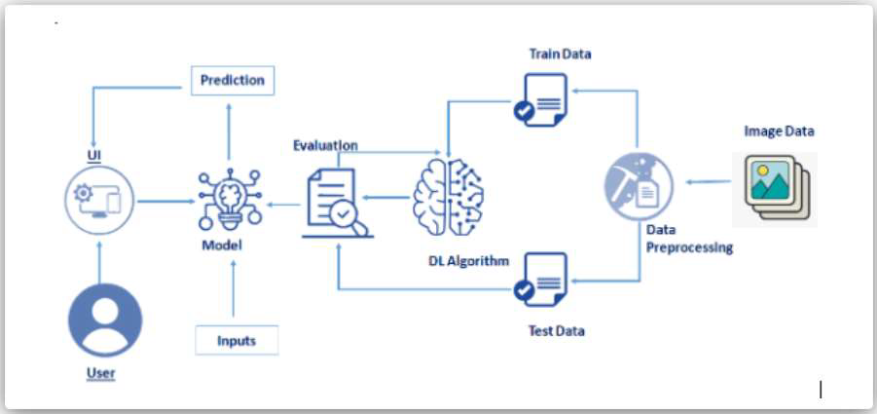

**Experimental Procedure of the CNN Model**

**5.1 Data collection**

Data collection is the process of gathering and measuring information on targeted variables in an established system, which then enables one to answer relevant questions and evaluate outcomes.

Data collection is a research component. We have used a dataset sourced from the web.

**5.2 Image Pre-Processing**

Image pre-processing is the name for operations on images at the lowest level

of abstraction whose aim is an improvement of the image data that suppress

undesired distortions or enhances some image features important for further

processing. It does not increase image information content.

We have used ImageDataGenerator library to augment our images in real-time while

the model is still training.

**rescale**: The ImageDataGenerator class can be used to rescale pixel values from the

range of 0-255 to the range 0-1 preferred for neural network models. Scaling data to

the range of 0-1 is traditionally referred to as normalization.

**shear_range**: 'Shear' means that the image will be distorted along an axis, mostly to

create or rectify the perception angles. It's usually used to augment images so that

computers can see how humans see things from different angles.

**zoom_range**: ImageDataGenerator class takes in a float value for zooming in the

zoom_range argument. You could provide a list with two values specifying the lower

and the upper limit. Else, if you specify a float value, then zoom will be done in the

range [1-zoom_range, 1+zoom_range]. Any value smaller than 1 will zoom in on the

image. Whereas any value greater than 1 will zoom out on the image.

**horizontal_flip**: ImageDataGenerator class has parameters horizontal_flip and vertical_flip for flipping along the vertical or the horizontal axis. However, this technique should be according to the object in the image. For example, vertical nipping of a car would not be a sensible thing compared to doing it for a symmetrical object like football or something else.

**rotation_range**: ImageDataGenerator class allows you to randomly rotate images

through any degree between 0 and 360 by providing an integer value in the rotation_range argument. When the image is rotated, some pixels will move outside

the image and leave an empty area that needs to be filled in.

**5.3 Model Building**

A machine learning model is built by learning and generalizing from training data, then applying that acquired knowledge to new data it has never seen before to make predictions and fulfill its purpose.

The layers used in model building are:

**Convolution Layer**: This layer is the first layer that is used to extract the various

features from the input images. In this layer, the mathematical operation of

convolution is performed between the input image and a filter of a particular size

MxM. By sliding the filter over the input image, the dot product is taken between the

filter and the parts of the input image with respect to the size of the filter (MxM). The

output is termed as the Feature map which gives us information about the image

such as the corners and edges. Later, this feature map is fed to other layers to learn

several other features of the input image.

**Pooling Layer**: In most cases, a Convolutional Layer is followed by a Pooling Layer.

The primary aim of this layer is to decrease the size of the convolved feature map to

reduce the computational costs. This is performed by decreasing the connections

between layers and independently operates on each feature map. Depending upon

method used, there are several types of Pooling operations. In Max Pooling, the

largest element is taken from feature map. Average Pooling calculates the average

of the elements in a predefined sized Image section. The total sum of the elements

in the predefined section is computed in Sum Pooling. The Pooling Layer usually

serves as a bridge between the Convolutional Layer and the FC Layer.

**Fully Connected Layer**: The Fully Connected (FC) layer consists of the weights and biases along with the neurons and is used to connect the neurons between two different layers. These layers are usually placed before the output layer and form the last few layers of a CNN Architecture. In this, the input image from the previous layers are flattened and fed to the FC layer. The flattened vector then undergoes few more FC layers where the mathematical functions operations usually take place. In his stage, the classification process begins to take place.

**Activation Functions**: Finally, one of the most important parameters of the CNN

model is the activation function. They are used to learn and approximate any kind of

continuous and complex relationship between variables of the network. In simple

words, it decides which information of the model should fire in the forward direction

and which ones should not at the end of the network. It adds non-linearity to the

network. There are several commonly used activation functions such as the ReLU,

Softmax, tanH and the Sigmoid functions. Each of these functions have a specific

usage. For a binary classification CNN model, sigmoid and softmax functions are

preferred for a multi class classification , generally softmax can be used

**5.4 Configuring the learning process**

**Configuring the learning process**:

* The compilation is the final step in creating a model. Once the compilation is done, we can move on to training phase.
* Loss function is used to find error or deviation in the learning process. Keras requires loss function during model compilation process.
* Optimization is an important process which optimize the input weights by comparing the prediction and the loss function.
* Here we are using adam optimizer Metrics is used to evaluate the performance of your model. It is similar to loss function, but not used in training process

**Training the model**:

* **steps_per_epoch**: It specifies the total number of steps taken from the generator as soon as one epoch is finished and next epoch has started. We can calculate the value of steps_per_epoch as the total number of samples in your training folder divided by the batch size.
* **Epochs**: an integer and number of epochs we want to train our model for. Validation_data can be either an inputs and targets list a generator an inputs, targets, and sample_weights list which can be used to evaluate. The loss and metrics for any model after any epoch has ended.
* **Validation_steps**: Only if the validation_data is a generator then only thisargument can be used. It specifies the total number of steps taken from the generator before it is stopped at every epoch and its value is calculated as the total number of validation data points in your dataset divided by the validation batch size.
* **Saving the Model**: The model is saved with .h5 extension as follows . An H5 file is a data file saved in the Hierarchical Data Format (HDF). It contains multidimensional arrays of scientific data.
* **Testing the model**: The last and final step is to make use of our saved model to do predictions. For that we have a class in keras called load_model. Load_model is used to load our saved model h5 file.

5.5 **Application Building**

**Insights from our work**

In this section, we have built a web application that is integrated to the model we built.

A UI is provided for the user where he uploads an image . The uploaded image is given to the saved model and prediction is showcased on the UI.

* **HTML page**:We use HTML to create the front end part of the web page. Here, we created 1 html page - index.html to display the overall UI of the webpage. We also used JavaScript-main.js and CSS-main.css to enhance ourfunctionality and view of HTML page.
* Building Python code:
  + Build flask file 'app.py' which is a web framework written in python for server-side scripting.
  + App starts running when "_name_" constructor is called in main.
  + render_template is used to return html file.
  + GET" method is used to take input from the user.
  + "POST" method is used to display the output to the user.

**Project Outcome And Results**

**6.1 Results**

We have attached the following screenshots as our project result:

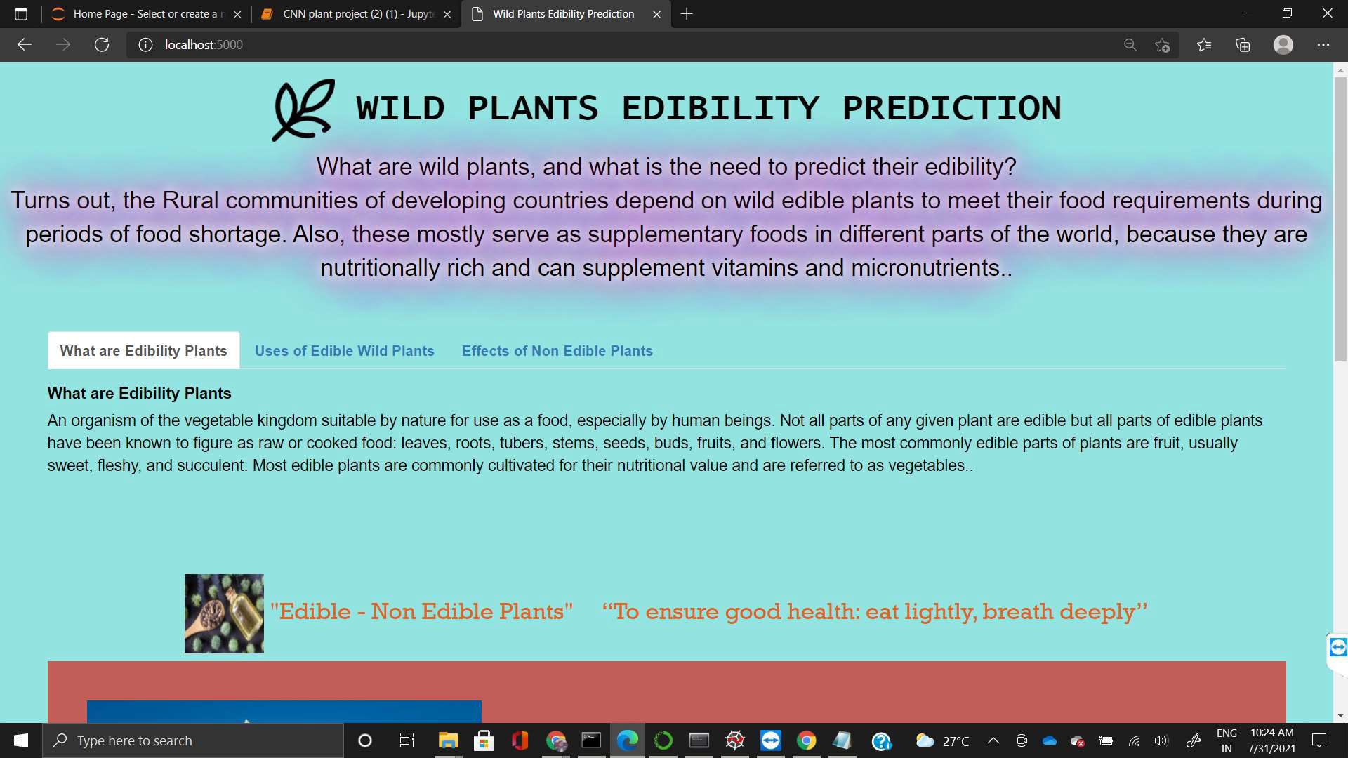

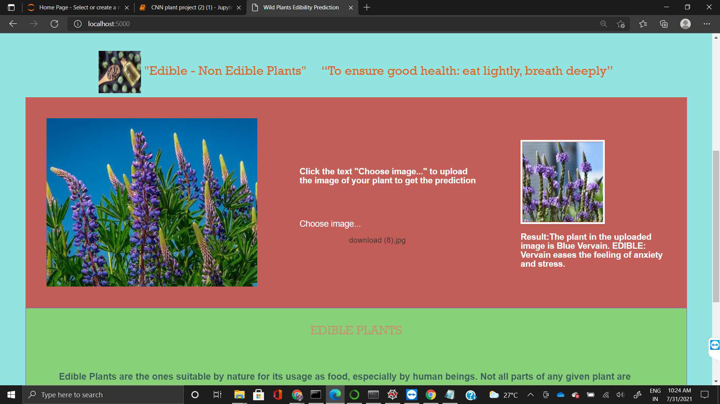

**Conclusion And Recommendation for Future Work**

**7.1 Conclusive Remarks**

The project works sufficiently well in predicting the edibility of an image of a wild

plant uploaded to it. The Model is accurate enough for the task. The use of Convolution neural networks greatly helps the use case as predicted.

The prediction and classification of wilds plants and their edibility is a powerful source to have for many use cases, for example, for adventurists to travel to remote areas with limited sources of food, for people living in villages where a staple source of food is wild plants.

The website created is intuitive to use, simple to understand and fast in it's response.

It provides ample knowledge of the plant picture uploaded to it.

**7.2 Future Enhancements**

Our team has aspirations to enhance the project further by the use of bigger and more varied datasets.

It would greatly improve the training of the model, leading to better predictions.

More functions can be added to the website to better suit the use case, like an option to click a picture with the website UI and give its prediction much like Google Glass .

**REFERENCES**

1. https://ieeexplore.ieee.org/document/9020302
2. https://ieeexplore.ieee.org/document/9010816
3. https://ieeexplore.ieee.org/document/9390835
4. https://ieeexplore.ieee.org/document/8567475
5. https://github.com/deepsworld/Edible-Wild-Plant-Classification-ResNet50-and-Keras